**Pl_SQL - Control Structures**

**Scenario 1: The bank needs to process monthly interest for all savings accounts.**

* **Question: Write a stored procedure ProcessMonthlyInterest that calculates and updates the balance of all savings accounts by applying an interest rate of 1% to the current balance.**

**SQL Query:**

CREATE OR REPLACE PROCEDURE ProcessMonthlyInterest IS

BEGIN

UPDATE Accounts

SET Balance = Balance + (Balance * 0.01),

LastModified = SYSDATE

WHERE AccountType = 'Savings';

COMMIT;

END;

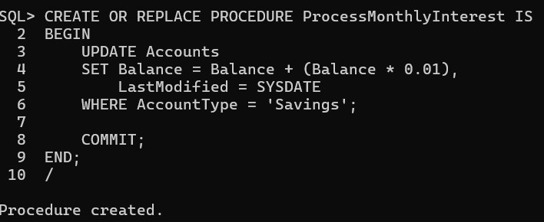

**Scenario 2: The bank wants to implement a bonus scheme for employees based on their performance.**

**o Question: Write a stored procedure UpdateEmployeeBonus that updates the salary of employees in a given department by adding a bonus percentage passed as a parameter.**

**SQL Query:**

CREATE OR REPLACE PROCEDURE UpdateEmployeeBonus(

p_department IN VARCHAR2,

p_bonus_percent IN NUMBER

) IS

BEGIN

UPDATE Employees

SET Salary = Salary + (Salary * p_bonus_percent / 100)

WHERE Department = p_department;

COMMIT;

END;

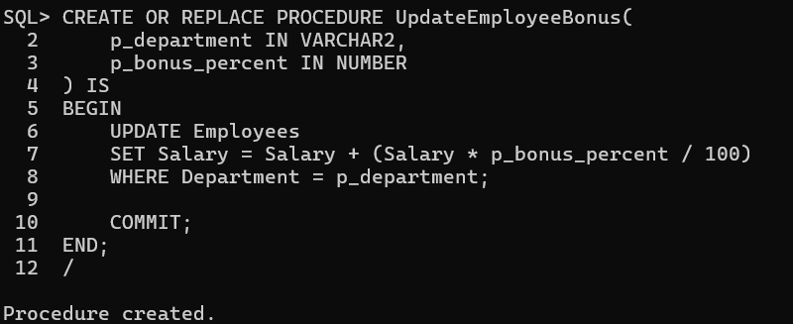

**Scenario 3: Customers should be able to transfer funds between their accounts.**

* **Question: Write a stored procedure TransferFunds that transfers a specified amount from one account to another, checking that the source account has sufficient balance before making the transfer.**

**SQL Query:**

CREATE OR REPLACE PROCEDURE TransferFunds(

p_from_account IN NUMBER,

p_to_account IN NUMBER,

p_amount IN NUMBER

) IS

v_balance_from NUMBER;

BEGIN

SELECT Balance INTO v_balance_from

FROM Accounts

WHERE AccountID = p_from_account;

IF v_balance_from < p_amount THEN

RAISE_APPLICATION_ERROR(-20004, 'Insufficient balance for transfer.');

END IF;

UPDATE Accounts

SET Balance = Balance - p_amount

WHERE AccountID = p_from_account;

UPDATE Accounts

SET Balance = Balance + p_amount

WHERE AccountID = p_to_account;

COMMIT;

EXCEPTION

WHEN OTHERS THEN

DBMS_OUTPUT.PUT_LINE('Error transferring funds: ' || SQLERRM);

END;

